Milton Elementary
C.A.P. Supply List
2019-2020 School Year

- Pencils
- Pencil case/box
- Whiteboard markers
- Highlighters
- Colored Pencils
- 2 - 2” binders
- 1 – 1” binder
- 2 folders (any color)
- Scissors
- Glue sticks
- 1 package of page protectors
- 3 packages of divider tabs
- 2 composition books
- 1 package of loose leaf paper
- Headphones/Ear buds
- The classroom, as a whole, will need tissues, hand sanitizer, and Clorox wipes.

This is for the C.A.P. classroom only.

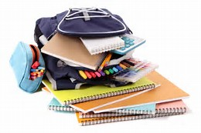

Incoming 5th graders can use last year’s binders if they are in good condition.

